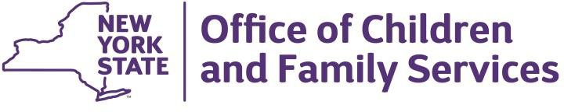

ANDREW M. CUOMO  Governor | SHEILA J. POOLE  Commissioner

January 11, 2021 Dear Provider,
Additional guidance has been released by the Department of Health (DOH) to expand the prioritized populations eligible
for a COVID-19 vaccination. The guidance is available at:
- https://coronavirus.health.ny.gov/system/files/documents/2021/01/guidance-for-week-5-oasas-ocfs-omh-otda- 1.11.21.pdf
- https://coronavirus.health.ny.gov/system/files/documents/2021/01/guidance-for-facilities-receiving-covid19- vaccine-1.11.21.pdf

As noted in the guidance, prioritized populations now include:
- Owners, Operators and staff of OCFS licensed and registered child care programs.
- Providers and staff of New York City based child care programs under article 43 and article 47 of the city health code. (Identified in the guidance as “approved child care”)
- Providers and staff of Legally Exempt Group Child Care programs
- In addition, school personnel have been added to the prioritized populations including:
  - P-12 school or school district faculty or staff (includes all teachers, substitute teachers, student teachers, school administrators, paraprofessional staff, and support staff including bus drivers
  - Contractors working in a P-12 school or school district (including contracted bus drivers)
No unlicensed, unregistered, informal or legally exempt home-based providers of child care are eligible at this time.

We encourage you to review all the guidance documents on the Department of Health’s website. We would like to draw your attention to some important points:
- Prioritized employers should work with their local health departments, hospitals and Federally Qualified Health Centers (FQHCs) to identify vaccination sites available to them and their staff. Additionally, the following link can be used to make appointments for eligible employees and service recipients/residents: https://am-i- eligible.covid19vaccine.health.ny.gov/
- All individuals receiving the COVID-19 vaccine must complete the New York State COVID-19 Vaccine Form for the first dose (see https://forms.ny.gov/s3/vaccine) to attest to eligibility for the vaccine.
- All recipients of the vaccine, or a person authorized by law to consent on their behalf, will be required to provide informed consent for the vaccine to be administered. The consent form is available on DOH’s website at: https://coronavirus.health.ny.gov/system/files/documents/2021/01/final_covid- 19_vaccine_consent_form.pdf.

Additional guidance from the NYC Department of Health and Mental Hygiene (DOHMH) will be forthcoming for those programs operating in NYC.

We are pleased that these essential staff are eligible to receive a COVID-19 vaccination and appreciate your efforts to support the vaccination effort.

Sincerely,
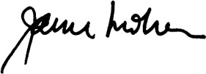
Janice M. Molnar, Ph.D.
Deputy Commissioner

Division of Child Care Services | 52 Washington Street, Rensselaer, NY 12144 │ (518) 474-9454 │ocfs.ny.gov

